# Lab 03 Template - Ethan Roepke

[Don’t forget to follow these lab report instructions.](https://docs.google.com/document/d/17YVskN9GQxI6Erjl8pq7goWKIcbaZ7PeJeYBoVwNsKg/edit?usp=sharing)

1. **Screenshot of passwd and shadow with description/notation of fields**

(10 points)

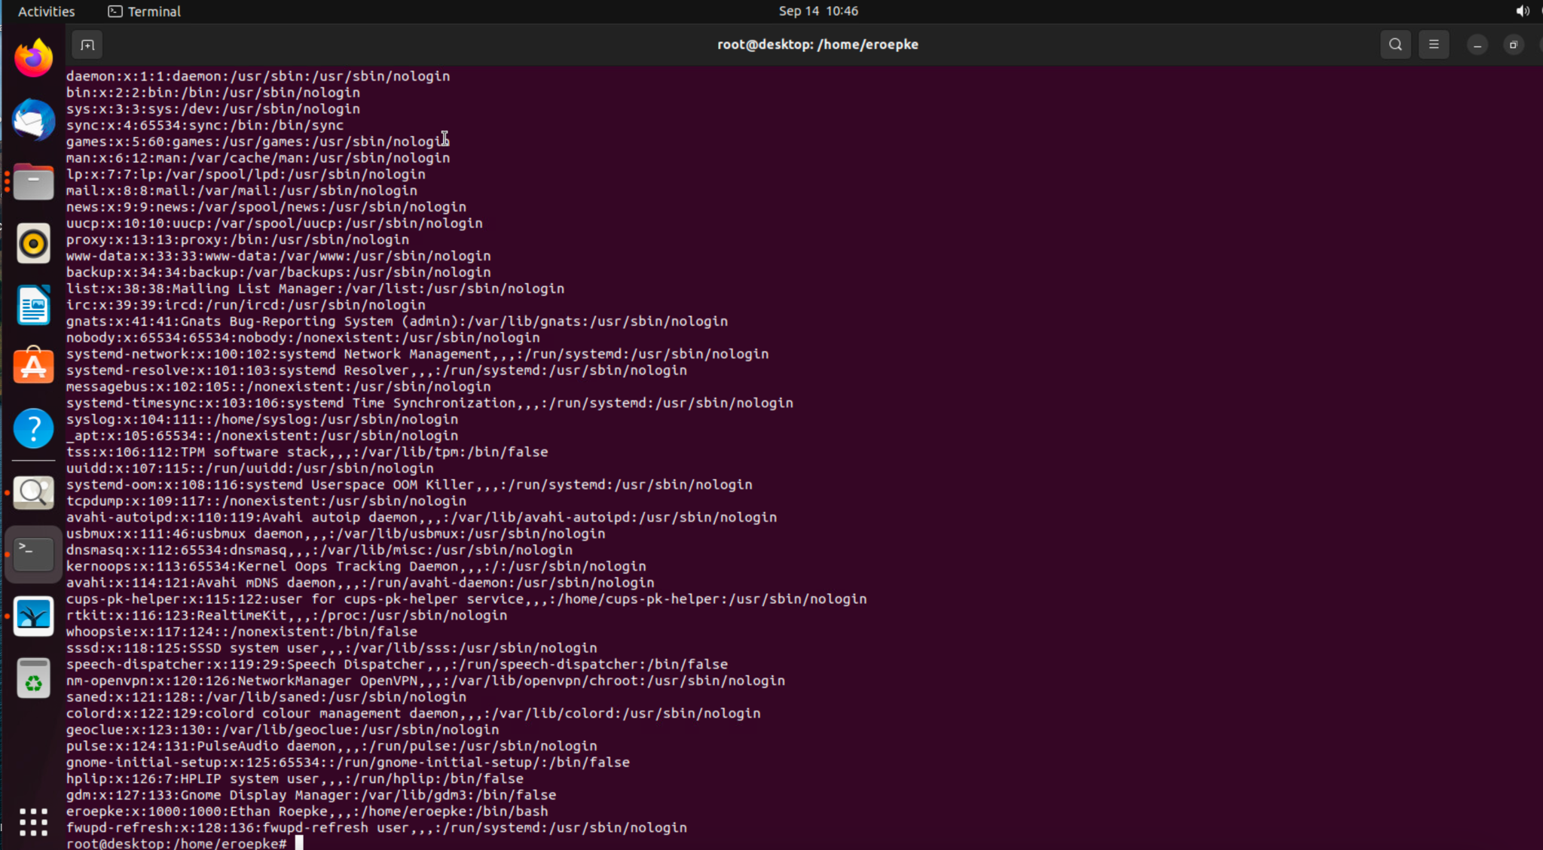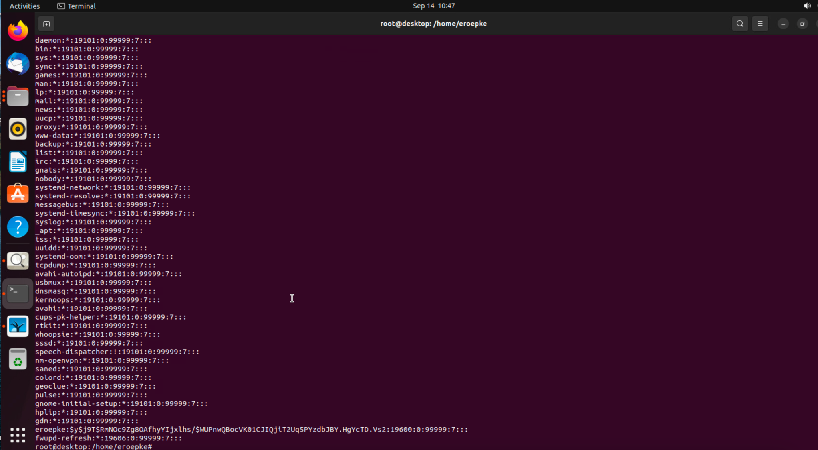

The /etc/passwd is a text file with information for al user accounts. It gives information such as User ID, group ID, home directory, and default shell.

The /etc/shadow file stores encrypted user passwords. Only the root user will be able to view to prevent from malicious actors.

1. **Screenshot of passwd and shadow in middle of user account creation**

(10 points)

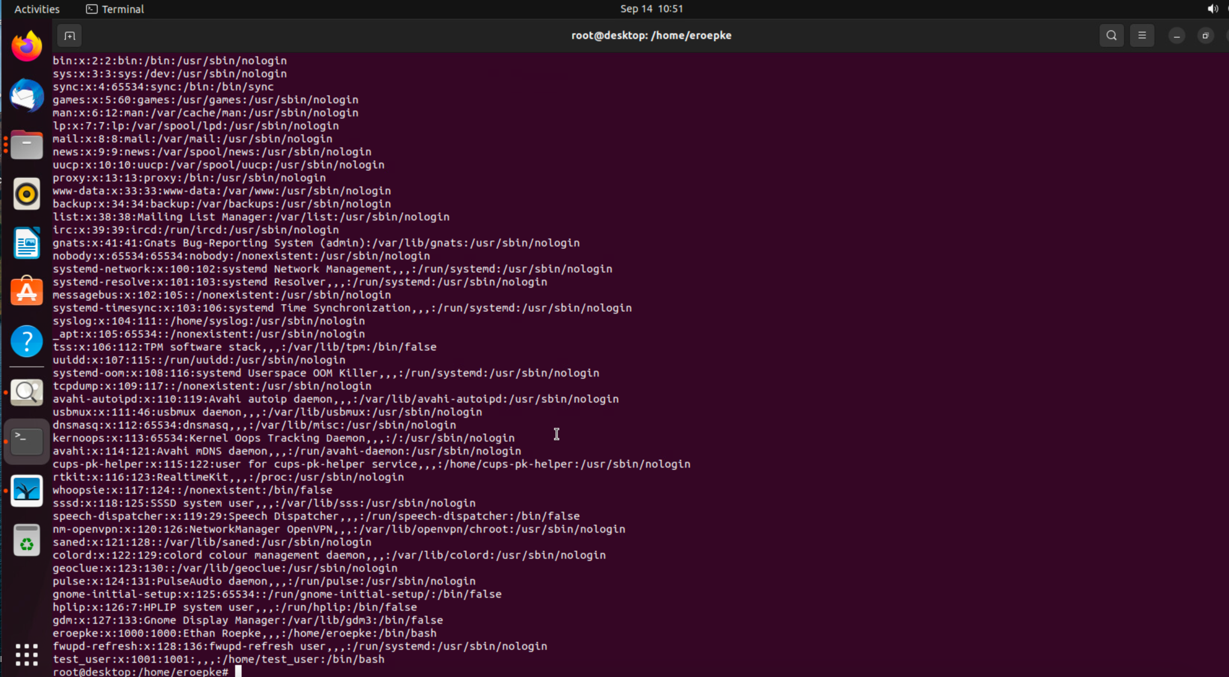

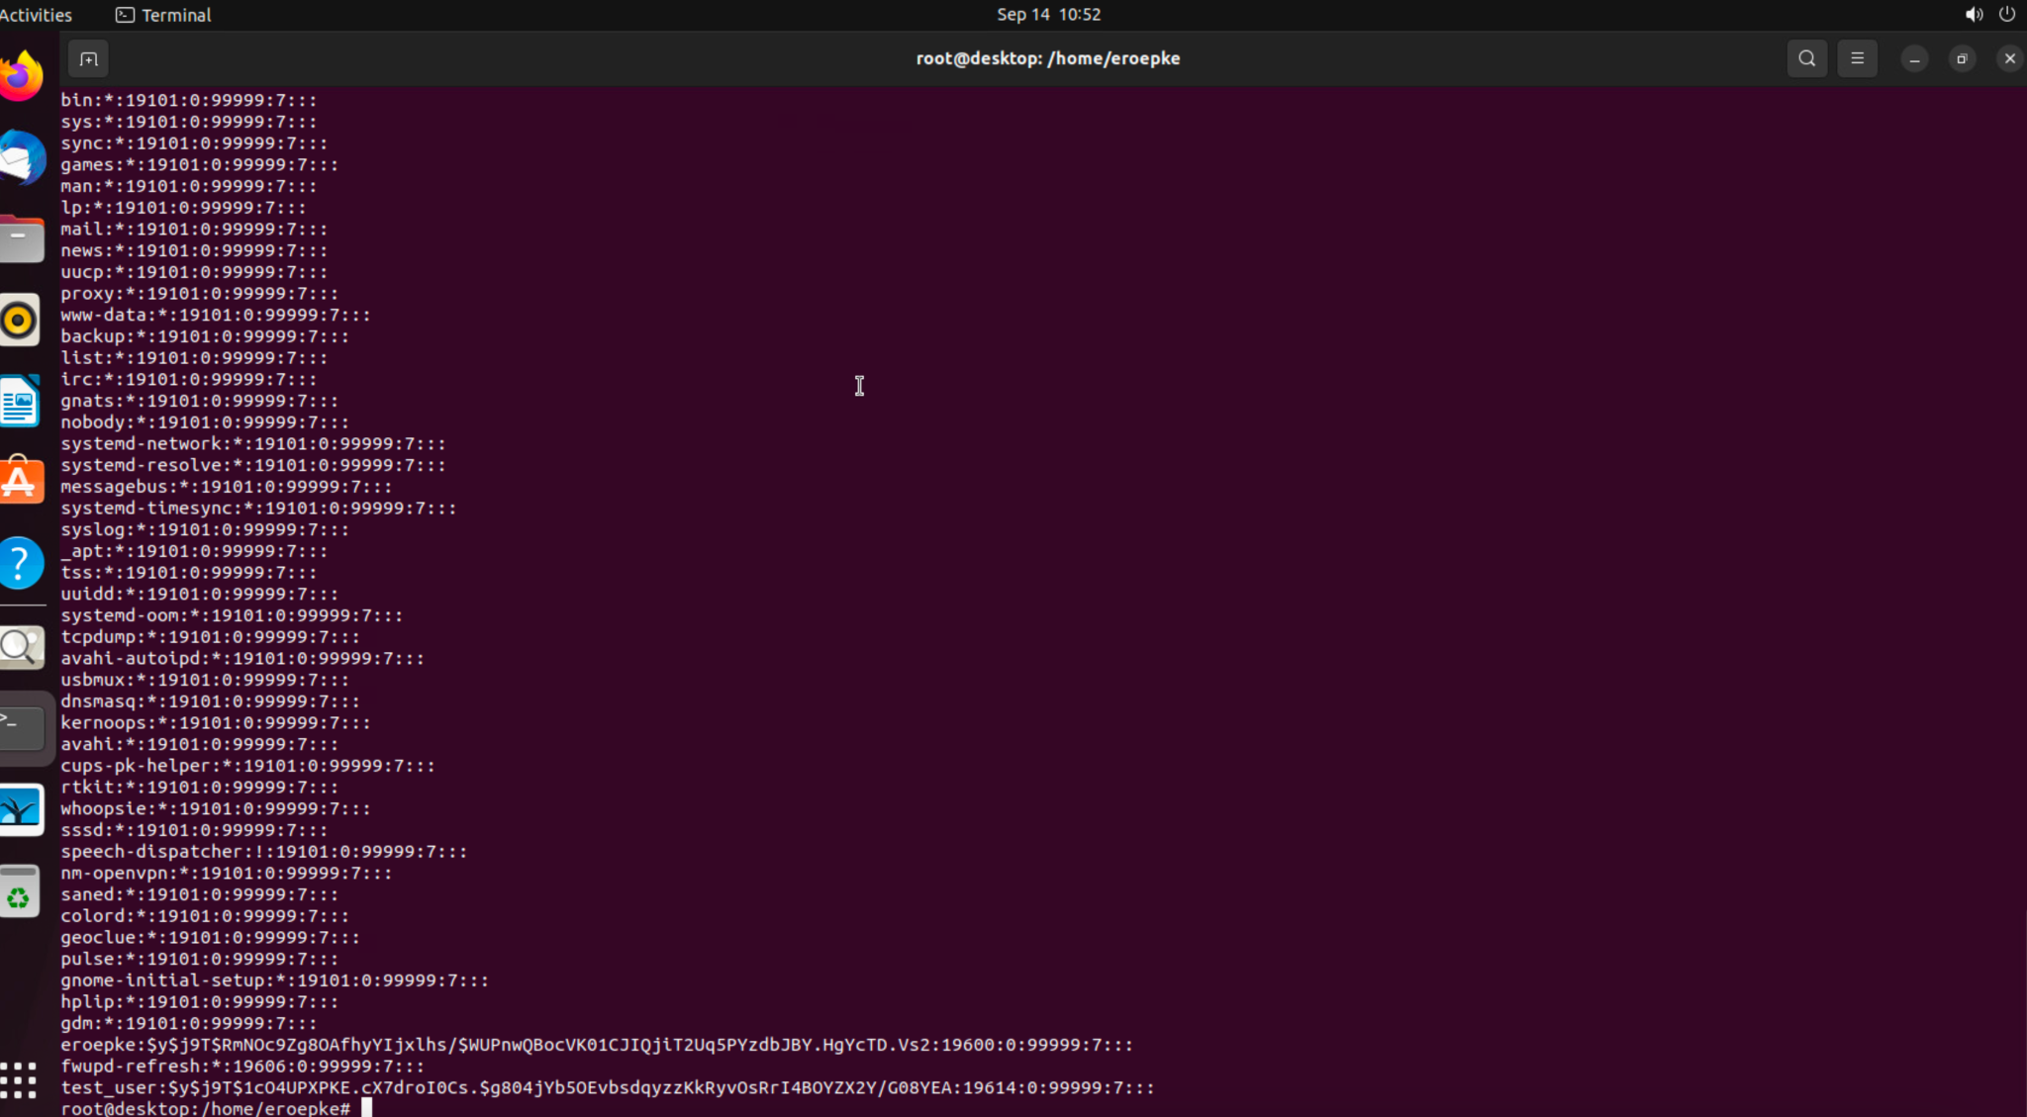

1. **Screenshot of new user’s home directory contents (ls -la) and the output of the environment variables (echo $USER $SHELL)**

(5 points)

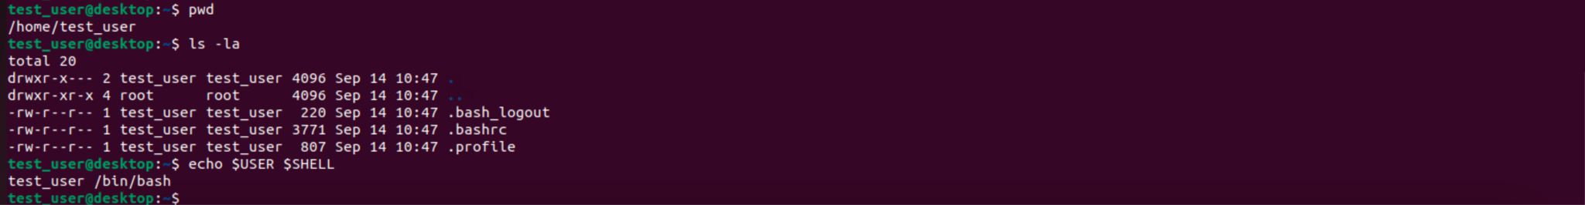

1. **Summarize the Key Differences between nologin and a locked password**

(5 points)

Nologin will prevent the user from logging in entirely and locked password will allow the user to login but will not allow them to change the password. A nologin would be used if you dont want a user to gain access to the system anymore while a locked password would be used if you want to prevent the user from changing the password from something else that you want to know.

1. **Description of the effect of each of the (5) chmod commands**

(10 points)

**chmod 777 *filename***-(-rwxrwxrwx) each number corresponds to user,group,and others. 7 gives access to read,write, and execute. 6 would gives access to read and write. 5 gives access to read and execute. 4 gives access to read. 3 access to write and execute. 2 access to write. 1 execute. 0 access to nothing.

**chmod 700 *filename***-(-rwx- - - - - -) user has access to read write and execute while group and others have no access.

**chmod u=rw *filename*** *-* letter before = indicates who it is(u,g,o). This is telling us user gets access to read and write but not execute. This will replace old access to the new access(old: ---e new:-rw-)

**chmod go+x *filename*** *-* letters before + indicated who it is(u,g,o). Here we are adding access to execute to group and others.

**Chmod a+w filename** - a represents all so user,group,others and added access to execute.

1. **Organized description of directory permissions and how affects contents**

(10 points)

The permissions determine who can read, write, and execute a file in the directory.

It as well determine who can change the permissions on the directory. Read permission on a directory gives you the ability to read the contents on the file. Write permissions allow you append, remove and rename a file. Execute permission allows you to have access files.

1. **Screenshot and description of /etc/shadow file - who can r/w/x and why it’s set this way.**

(10 points)

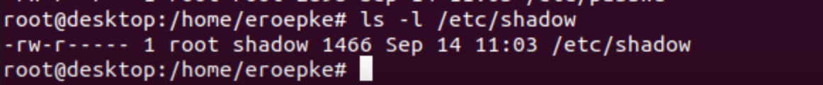

It is set up this way becasue shadow contains password hashes and we do not want to give access to others to see at all and allow a group to see. Only the user should be able to read and write. You dont want to allow others to gain access and do attacks.

1. **Meanings of dig queries**

(10 points)

|  |  |
| --- | --- |
| Query | What does the query result mean? |
| dig -t mx iastate.edu | Retrieve DNS records and tells mail how to route mail to domain |
| dig -t ns iastate.edu | Map a domain name to list of DNS servers for that domain |
| dig -t soa iastate.edu | Stores important information about a domain |
| dig -t aaaa iastate.edu | Domains are assigned the IPv6 address for a destination |
| dig -t any iastate.edu | Shows all domain records and assigned to any |

1. **Screenshot of the (2) netstat outputs**

(10 points)

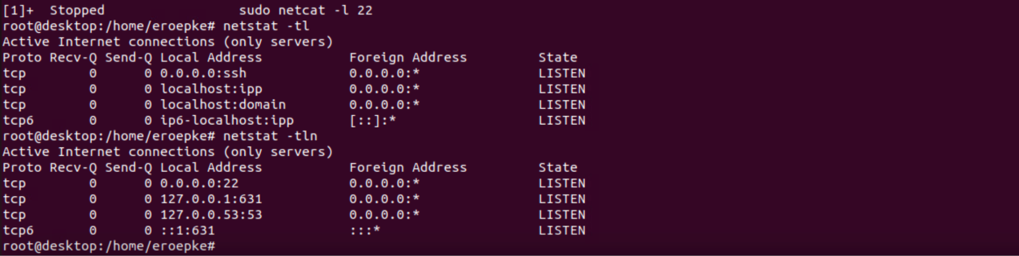

1. **Complete the netstat flag table**

(10 points for all 3 correct meanings; 0 points for anything less)

|  |  |
| --- | --- |
| Flag | Meaning |
| -t | Sort by time, newest first |
| -l | Show only listening sockets |
| -n | Show number addresses instead of determining host,port, or user name |

1. **Screenshot of the captured http traffic using Wireshark**

(5 points)

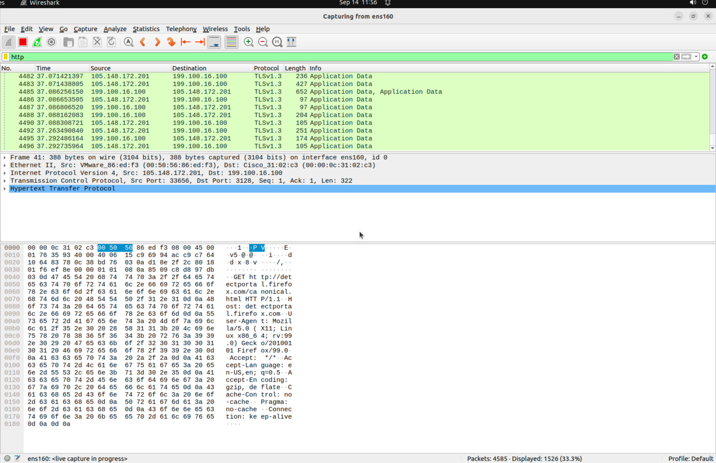

1. **Screenshot of the captured icmp traffic using tcpdump**

(5 points)

